Web Page
rscdswestlothian.org.uk

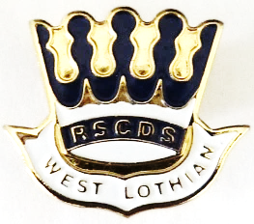
Royal Scottish Country
Dance Society
West Lothian Branch
Scottish Charity No SC009088

Welcome to our
Annual Dinner
Dance

Saturday 5th December 2026
Canon Hoban Hall
34 West Main Street, Broxburn, EH52 5RJ
6.00pm for 6.30pm
Music by
Lindsay Weir and her Scottish Country Dance Band
The dance will commence with a hot meal being served at 6.30pm prompt and dancing starting at 8.00pm approximately. As in previous years, bar facilities will be available therefore do not bring your own alcohol. Dress, as always, is optional.

J  R  S  J  R  S  J  R  J  S  R  J  S  R | EH3 7AF  The Falls of Rogie  Fair Donald  Kathy’s Fascinator  Glastonbury Tor  Mrs Milne of Kinneff  Welcome to Ayr  The Lass of Richmond Hill  The Roselath Cross  The Platinum Strathspey  Trip to Timber Ridge  Follow Me Home  The Byron Strathspey  Mairi’s Wedding | 40  Attwood  29  54  47  RSCDS/L  47  Turnbull  41  WL 70  52  38  Drewry  Cosh
Application Form
Please return the undernoted form, indicating how many tickets you wish, not forgetting to enclose a stamped addressed envelope (C5, 21cm x 16cm) to:-
Mrs Jean Finch
6 Robertson Way
Livingston
EH54 8RE
Telephone 01506 441364
Email: jeanannfinch@hotmail.com
Crib sheets available on the web page www.rscdswestlothian.org.uk
Dinner and Dance £30

Name ………………………………………………………………………………
Address ……………………………………………………………………………
………………………………………………………………………………………..
Post Code ………………………… Tel ………………………………………
Vegetarian (please tick)
……………. Tickets @ £30 per person Total £…………..
Cheques payable to RSCDS West Lothian

